**Image File (Medium)**

**We found a USB used by a hacker, can you determine some information?**

**What Operating System installer is this? (not the kernel)**

1. Run the Mysterious.iso file.
2. Boot 🡪 isolinux 🡪 f1

Answer: tinycore

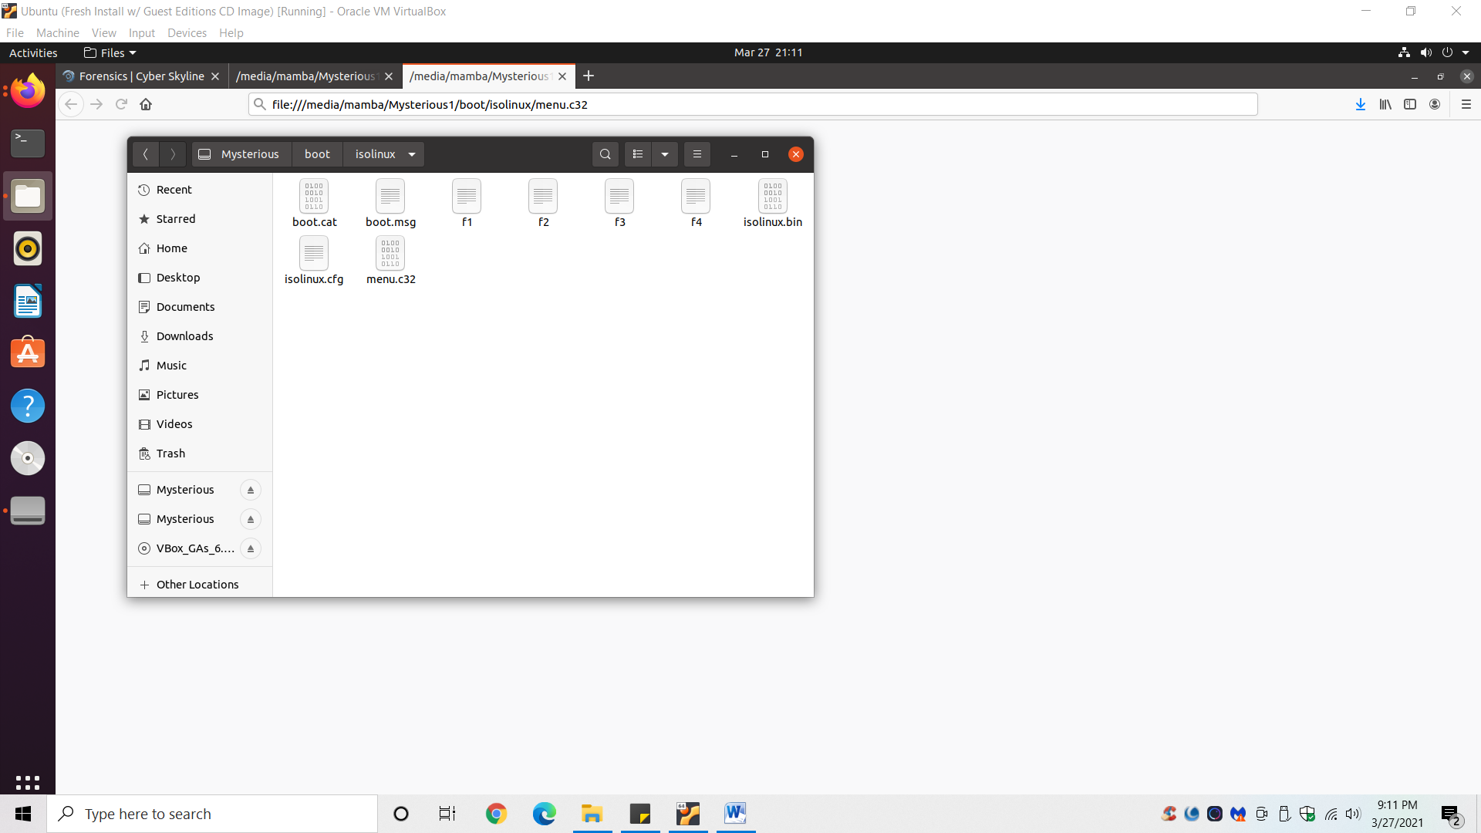

**What version of the OS does it install?**

**???**